**Manuals and Report**

The program was written in Java 11 using Intellij

After compiling the program, the main menu will be displayed like this:

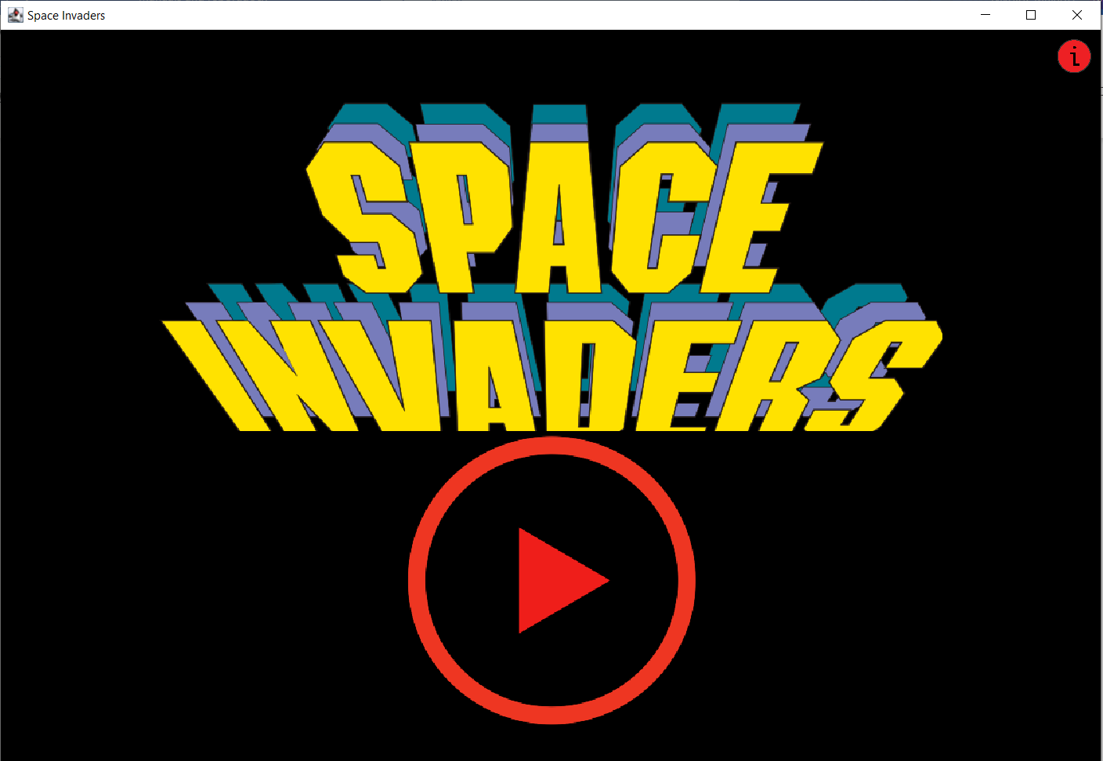

The button at the top-right corner is the instructions button that will display how to play the game (instructions), rules and special powers:

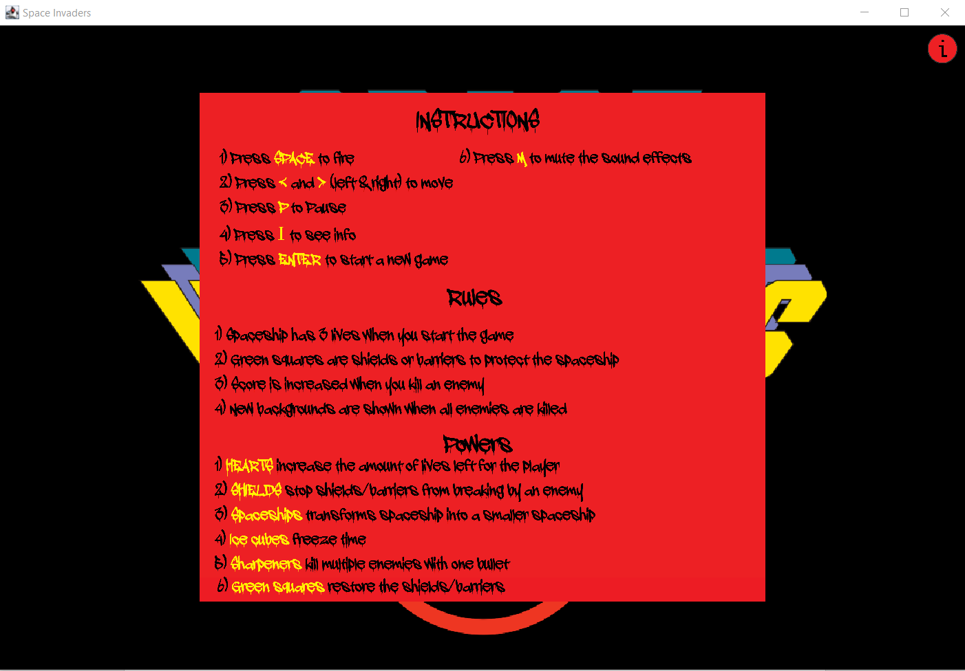

The font used in instructions is called “a dripping marker”.

1) Press Space to fire

2) Press < and > (left & right) to move

3) Press P to pause

4) Press I to see info

5) Press Enter to start a new game

6) Press M to mute the sound effects

Rules:

1) Spaceship has 3 lives when you start the game

2) Green squares are shields or barriers to protect the spaceship

3) Score is increased when you kill an enemy

4) New backgrounds are shown when all enemies are killed

Powers:

1) Hearts increase the amount of lives left for the player

2) Shields stop shields/barriers from breaking by enemy

3) Spaceships transforms spaceship into a smaller spaceship

4) Ice cubes freeze time

5) Sharpeners kill multiple enemies with one bullet

6) Green squares restore the shields/barriers

To exit out of the instructions view press the instructions button again or press enter to start the game.

The Start icon in the middle can be also pressed to start the game.

Once you start the game the following view will be available:

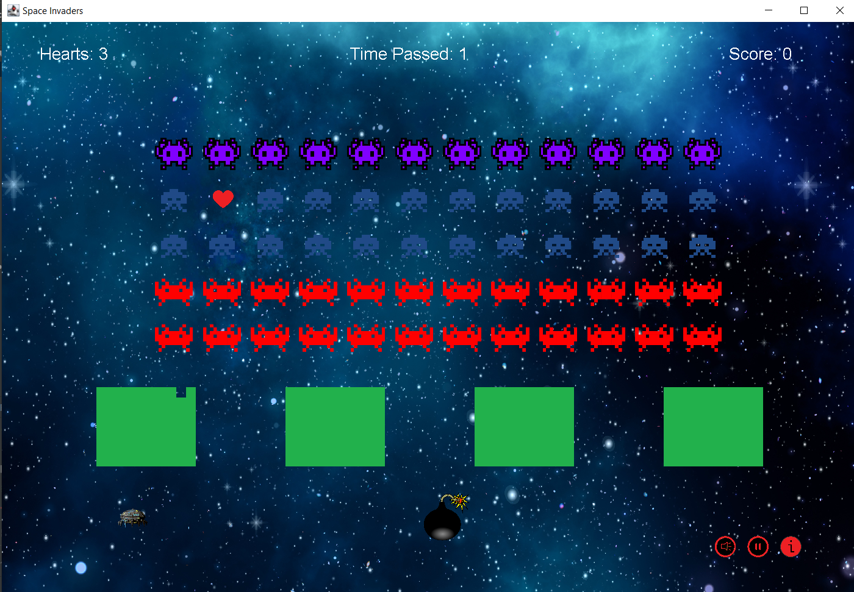

The game is simple, you must move the spaceship and shoot enemies to progress to the next stage. Once you kill an enemy you get score points, and once you finish the stage you get +100 score points, that is shown at the top-right corner of the screen. The top-middle shows time passed since the game has started and the top-left corner of the screen shows hearts/lives left until you die. Hearts are decreased once you get hit by the enemy projectiles that look like bombs. The projectiles you shoot look like bullets. Hearts can be increased after popping the enemy hearts that appear instead of the enemy. Powers are present instead of the enemy over the period so the enemies might transform into these powers. Once you pop these powers you activate them and some of them are time dependent, and the timer until they stop appears under the Time Passed statistic.

Enemies start moving from left to right and change their direction to right to left once the furthest enemy reaches the end of the screen (horizontal). And they continue to move in such manner until one of the enemies reach below the spaceship where the game is over. Also their movement speed is increased every stage, making each stage harder.

Bullets you shoot can also damage green shields that leave empty space behind them. Apart from the enemies shown on the screen there is also a flying enemy that might appear any time which flies from left to right on top of these enemies.

The buttons at the bottom-left corner can be either pressed or activated by pressing buttons specified in the instructions. The first one mutes the sound effects that are in the game, you can click it again to unmute. The second one is Continue/Pause that is triggered once you click it, which pause the gameplay. The last one is an instructions button that also pauses the gameplay which shows instructions just like in the screenshot above.

Once you lose the following screen is shown, displaying game over, score and time passed when you lost.

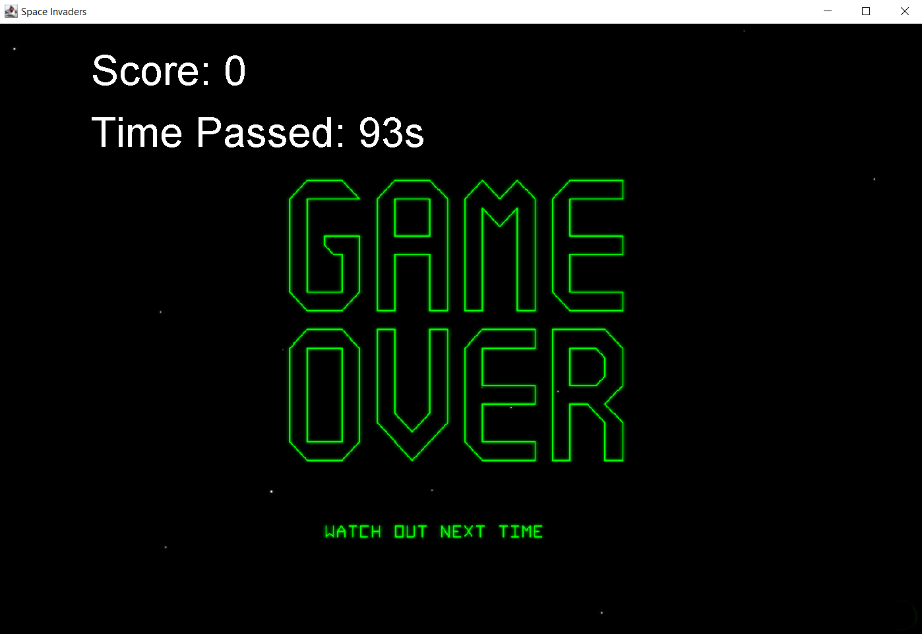

To exit out of this screen, again just press anywhere on the screen or press enter.

The game has 4 stages that are in the loop, which means they are shown repeatedly once you progress to the next stage. Here are these 4 backgrounds, that’s the only thing that changes during these stages.

Stage 1:



Stage 2:

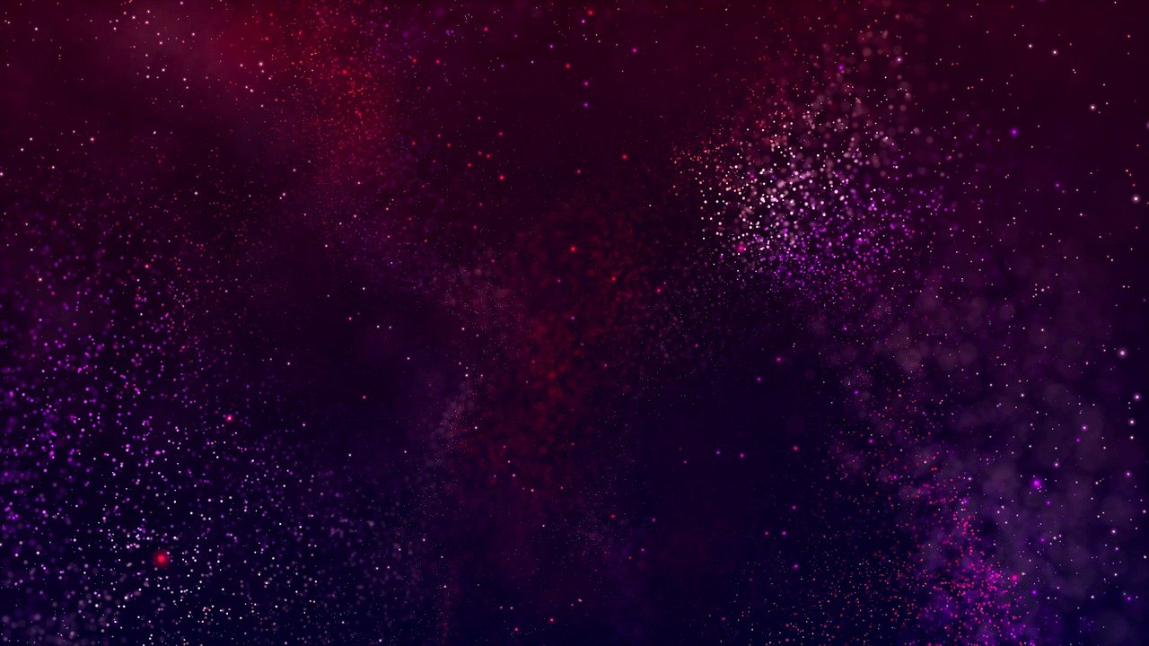

Stage 3:

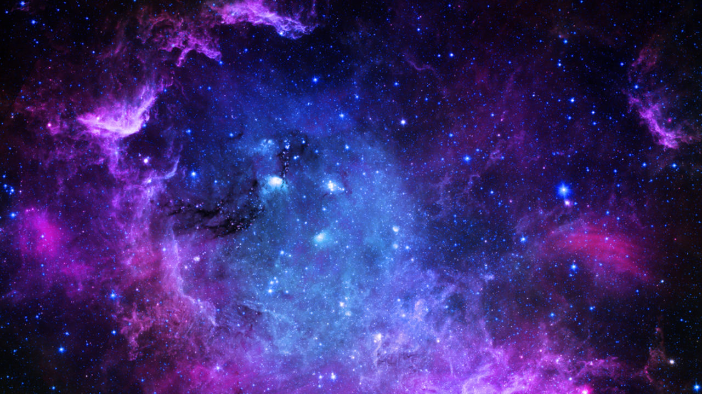

Stage 4:



I used 5 sound effects for the game, which I downloaded from here:

<https://www.classicgaming.cc/classics/space-invaders/sounds>

References to sprites used in the game:

<https://freepngimg.com/png/32295-space-invaders-transparent-background>

<https://freepngimg.com/png/32282-space-invaders-free-download>

<https://freepngimg.com/png/32291-space-invaders-transparent-picture>

<https://freepngimg.com/png/25214-spaceship-transparent>

<https://freepngimg.com/png/25066-spaceship-picture>

<https://freepngimg.com/png/81313-sound-sonic-flower-explosion-symmetry-boom>

<https://www.pngwing.com/en/free-png-bxenk>

<https://freepngimg.com/png/4054-bullets-png-image>

<https://www.pngwing.com/en/free-png-pgtsl>

<https://upload.wikimedia.org/wikipedia/commons/thumb/1/18/Space_invaders_logo.svg/1000px-Space_invaders_logo.svg.png>

<https://freepngimg.com/png/15681-sharpener-png>

<https://freepngimg.com/png/6930-shield-png-image-picture-download>

Any other sprites where made by me either in Photoshop or Paint.

The src consists of 7 classes:

1. Enemy.java
2. Main.java
3. Pictures.java
4. Player.java
5. Projectile.java
6. Shield.java
7. SoundManager.java

The other 2 are folders called Images and Audio.

SoundManager.java was taken from the labs and adjusted to suit the game.

Shield.java, Projectile.java, Enemy.java, Player.java are classes that implement objects for the game.

Pictures.java is a class that loads the sprites to later use in the game

And Main.java is the main class that has a main method to compile and run the game, which uses all the 6 classes mentioned above.

To put it simple I implemented following required features from Part A: Game Basics:

* An easily manoeuvrable space ship (moves left and right)
* Bullets with appropriate velocity and time/ distance to live (projectiles shot by both the player)
* Basic enemy ships or canons that shoot bullets (Enemies shoot bombs to kill the Player)
* Proper game rules (loss of life, scoring of points)
* Multiple lives and/ or multiple game levels

Part B: Further Game Features:

* Visual and sound effects
* Game objects such power-ups, treasures which increase the score, items which need to be collected to activate some game feature or advance to the next level, etc. Some of these objects may only be available for a limited time or they may be spawned by enemies which need to be defeated first.
* A protective, rechargeable "energy shield" which keeps the ship safe from bullets or collision damage as long as there is sufficient shield power left and the shield is switched on. (Shields in this game are for this purpose so I’m guessing it’s identical)
* Different kinds of enemy ships with AI controllers, possibly spawning more advanced weapons such as mines or heat-seeking missiles. (I would say partially implemented because there are 4 different kinds of enemies, red, blue, purple and flying enemy and they use randomness to shoot the missiles, apart from the flying enemy, so it’s something close to be an AI controller.)

In Conclusion, the game wasn’t very hard too implement, as it uses the simple logics of translating vectors to move objects, any other GUI was also simple to implement. The most challenging part for me was implementing collision detection when the player hits both enemy and shields (that deform) and enemies that hit player with the bombs. The other challenging bit was implementing game AI, I was thinking about too complex things like algorithms and so I had no idea about how to implement that but eventually I came up with checking each columns bottom row enemy that makes them eligible for shooting their projectiles(bombs) and then randomize who will be shooting next over time.